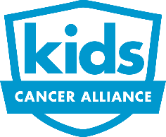 | Kids Cancer Alliance  Survivor Scholarship Application 2023

Academic Report
The KCA Scholarship fund was established to support young adult cancer survivors and to assist them in pursuing their academic and professional goals. The scholarship is designed to ease the financial burden of obtaining an education from an accredited university, community college, vocational or technical school.

Please have a school official complete the following academic report and send it directly to Kids Cancer Alliance by April 15th.

Physical Mailing Address: Kids Cancer Alliance, P.O. Box 24337, Louisville KY, 40224
Email: leah@kidscanceralliance.org

Name of Student:________________________________________________________

Grade Point Average (unweighted, based on a 4.0 scale):_________________

Rank in class:_____________ Size of graduating class:______________

Applicants highest SAT/ACT score:___________________________________

Is there any additional information you would like to share about this student’s academic performance?
________________________________________________________________________________________________________________________________________________________________________________________________________________________________________________________________________________________________________________________________________

This information has been completed by:

Name:_____________________________________________________________________________

Title:____________________________________________ Date:_________________________

May we contact you if we have additional questions?_____________________

Email:___________________________________________ Phone:_______________________

